# Crystal Reports General Guide

This is a guide to creating crystal reports in a standard professional format.

[R] = Reports only, [D] = Document formatting

Contents

Crystal Reports General Guide 1

Use Guidelines, rulers and grids when editing [R][D] 2

Don’t fill to the edge [D] 3

Don’t write reports that only work for one company [R] 3

Do not report directly from database tables [R][D] 4

Do use consistent formatting [R][D] 4

Do include red tag logging [R] 5

Do embed SQL stored procedures directly into crystal reports [R][D] 6

Sub Reports [R][D] 6

Align fields [R][D] 7

Don’t use Borders [R][D] 7

Don’t use lines [R][D] 8

Do use horizontal coloured sections [R][D] 8

Do use drawing objects [R][D] 8

Do keep the same fonts throughout an entire document [R][D] 9

Do keep the font the same size [R][D] 9

How to create borders [R][D] 10

Do not develop directly on the live Server [R] 11

Do not create user defined items on transactional databases [R][D] 11

Source Control [R][D] 12

## Use Guidelines, rulers and grids when editing [R][D]

What?

Just like in word and excel, Crystal has guideline, ruler and grid functions.

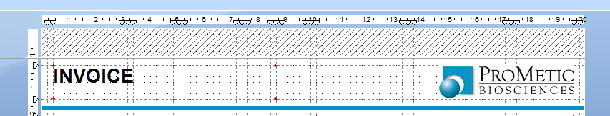

Why?

Ruler – this allows for accurate measuring of how a document is laid out. Grids – these allow easy view to see when fields aren’t aligned. Guidelines – these allow fields to be aligned to a single line, this line can then be moved and all the attached fields will move with it.

How?

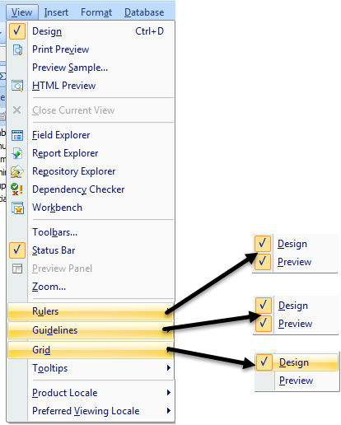

Select the view menu and turn these options on. Grid is not turned on for preview as this can affect the sight of the finished product within crystal.

## Don’t fill to the edge [D]

What?

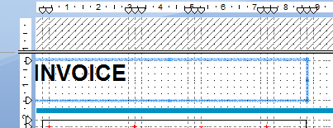

Don’t place fields directly at the edge of a page

Why?

Placing fields directly on the edge of page can lead to problems with printing, fields on the edge of a page can be cut off.

How?

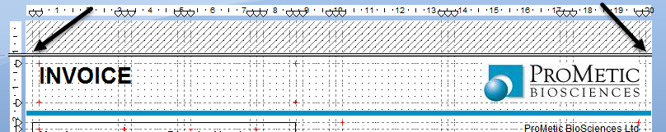

Use Guidelines to draw an inner border that you can align fields to.

## Don’t write reports that only work for one company [R]

What?

Going forward all reports should be written to be company “agnostic”, requiring a company parameter to run.

Why?

Without this, reports in test companies are not the same documents as those kept in live and invalidates any testing

How?

A SQL stored procedure should be written in the BlackBox database to return required values.

## Do not report directly from database tables [R][D]

What?

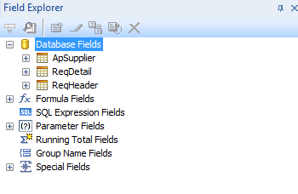

Linking directly to tables within live databases

Why?

Linking tables directly in crystal limits the report to work only in one company, there are no controls over how the data is recalled and no audit trail is left on running the report

How?

A SQL stored procedure should be written in the BlackBox database to return required values.

## Do use consistent formatting [R][D]

What?

Decimal places and dates in reports and documents should all be formatted the same way, ideally with a legend to describe the formatting where necessary (for example dd/mm/yyyy)

Why?

Mixing decimal places and date formatting can lead to reports not being understood or unclear when presented.

How?

Agree ahead of time how many decimal places and the date should be used, then apply this using format painter to all affected fields.

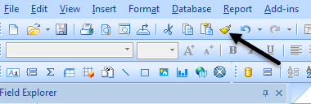

## Do include red tag logging [R]

What?

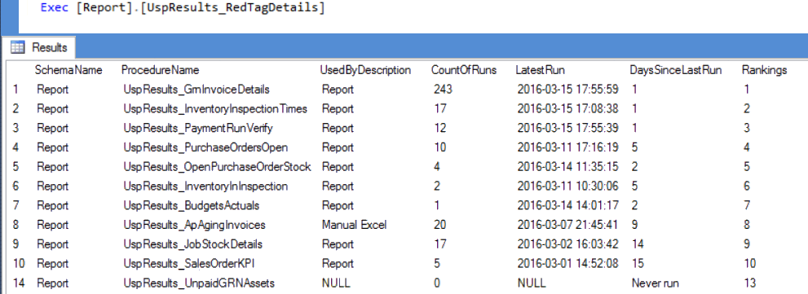

Adding records of when each report was run

Why?

By recording when each report was run, we can determine when reports are no longer in use and which reports might be causing system issues

How?

All stored procedures should be written to include the red tag inserts as below

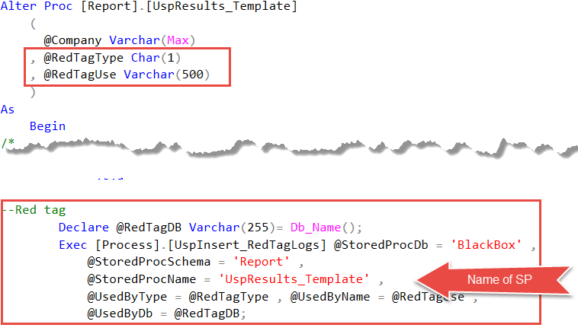

## Do embed SQL stored procedures directly into crystal reports [R][D]

What?

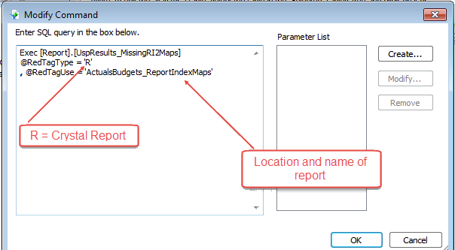

Creating SQL Code within crystal to pass hidden parameters to stored procedures

Why?

This allows the use of red tags without having to present them to users and relying on them completing the details.

How?

When creating a database connection, choose

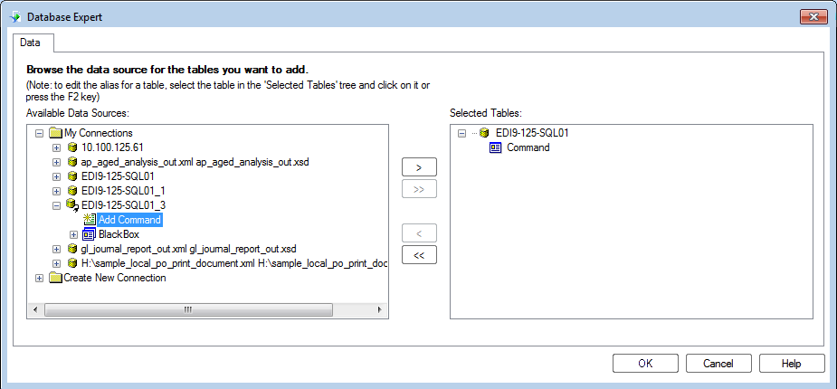

## Sub Reports [R][D]

What?

Sub reports are a function that allows a crystal report to call in additional data.

Why?

This allows unrelated data or data that would cause duplications to be shown without this happening. They should be used as sparingly as possible as they are very data heavy and have a significant impact on how long it takes to produce a report. Sub Reports are run during the printing of a document and are run for every line they appear on. They also have separate ruler, grid and guidelines setup.

How?

In order to ensure the best use of sub reports, they should only be used to pull back minimal information. When creating sub reports, by default they will include borders. To align the sub report to the main report these should be removed and the sub report should be aligned to the edge of report and then an inner border drawn within the sub report.

## Align fields [R][D]

What?

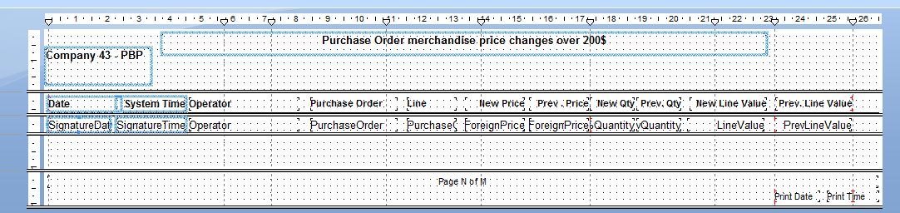

Align the tops, sides and bottoms of fields that are related. This is an example of where it has not been done.

Why?

Fields should not overlap and should be in line. This also allows for the data to be exported to excel without the need for manual manipulation.

How?

Vertical and horizontal guidelines can be used to align fields

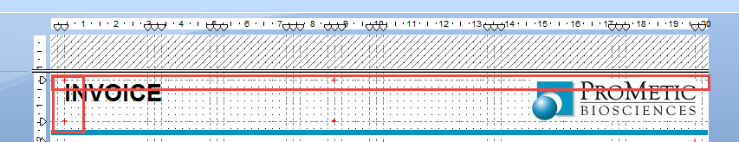

## Don’t use Borders [R][D]

What?

Fields should not have borders.

Why?

Fields with borders cannot be aligned, borders created in crystal are in addition to the field size. Borders are also untidy and overly busy when it comes to design.

How?

If a horizontal border is required, the section can be coloured. If a field needs to be differentiated, the field can be coloured.

## Don’t use lines [R][D]

What?

Page lines should not be added to reports.

Why?

Page lines cannot be aligned

How?

Vertical lines can be achieved by colouring fields. Horizontal lines can be achieved by adding “a section below” to the section you want to add a line to, adding a colour to the section and resizing it. Smaller lines can be created using drawing objects.

## Do use horizontal coloured sections [R][D]

What?

Sections can be added in different colours to allow a distinct break between data.

Why?

Sections instead of lines or drawing objects do not need to be aligned as they fill the entire page.

How?

Right click your section and add “a section below” to the section you want to add a line/break to, adding a colour to the section and resizing it to fit.

## Do use drawing objects [R][D]

What?

Boxes can be drawn within your document

Why?

These can be used add blocks of colour and can be aligned to fields already in a report.

How?

This button on the design pane allows you to draw boxes

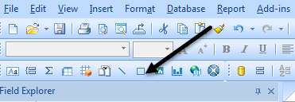

## Do keep the same fonts throughout an entire document [R][D]

What?

A single font should be used in a document/report

Why?

This promotes a professional “finish” in a report and document and makes it easier to read for the end user.

How?

Selecting all fields and applying changes will cause a lot of formatting to have to be redone. Instead, apply a font to one field (Suggested fonts are Verdana, Calibri, Arial) and then use the format painter to apply this to other fields.



## Do keep the font the same size [R][D]

What?

Each section of the report should have the same size.

Why?

Making the font the same size on a line makes it easier to read and line up details. It also gives a professional finish to the report/document.

How?

Selecting all fields and applying changes will cause a lot of formatting to have to be redone. Instead, apply a font to one field (Suggested fonts are Verdana, Calibri, Arial) and then use the format painter to apply this to other fields.



## How to create borders [R][D]

What?

If there is no other choice available, the below method can be used to create borders.

Why?

Borders created by default in Crystal do not align to fields, using boxes directly around a field cause a

How?

Create an outline using guidelines as below

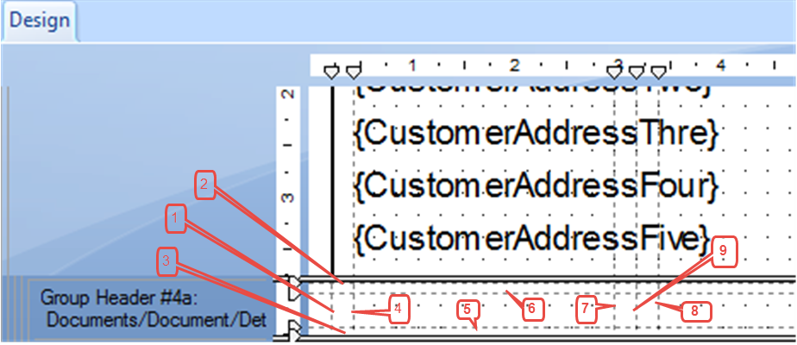

1 = Left Outside Border

2 = Upper Outside border

3 = Lower Outside border

4 = field left edge

5 = field lower edge

6 = field upper edge

7 = field right edge

8 = if adjacent field then right outside border and next field left edge, else not required

9 = if no adjacent field then right outside border, else next field left outside border

Then add a box, lining it up with the guidelines as below

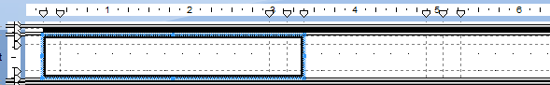

Then colour the box and add a second if the next field requires a border as well

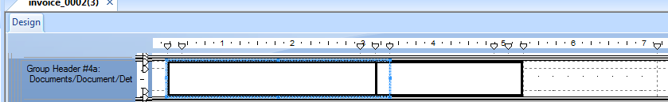

As you can see, the boxes overlap so the border is not double width

The add the fields, aligning to the inner border guidelines



The use of guidelines ensure that the borders are the same on each field.

## Do not develop directly on the live Server [R]

What?

Stored procedures, views and tables should not be created or changed directly on the live server (the server that hosts Syspro transactional data)

Why?

There are dangers inherent in developing on the live server, including but not limited to

* Cause the server to slow down, affecting business users
* Implement an incorrect change, immediately affecting the business

In addition, the live server is not linked to Source Control and backups are only performed once a day.

How?

Install SQL server on a local machine, request a back-up of the Syspro company to be queried, link in Red Gate Source Control and the BlackBox database.

## Do not create user defined items on transactional databases [R][D]

What?

Views, tables and stored procedures should not be created on any database other than BlackBox

Why?

There are dangers inherent in developing on transactional databases, including but not limited to

* Cause the databases to slow down, affecting business users
* Implement an incorrect change, immediately affecting the business
* Have changes overwritten by an upgrade to Syspro

In addition, the live server is not linked to Source Control and backups are only performed once a day.

How?

Install SQL server on a local machine, request a back-up of the Syspro company to be queried, link in Red Gate Source Control and the BlackBox database.

## Source Control [R][D]

What?

Source control is the management of changes within the database.

Why?

Source control allows us to see previous versions of reports and stored procedures so that in the event of a failure these can be rolled back.

How?

All Source Control is held within GitHub on the repository [Blackbox](http://github.com/dontlookaway/BlackBox) (note this repository is restricted to exclude public access).

SQL is automatically generated and stored into GitHub using Red Gate Source Control.

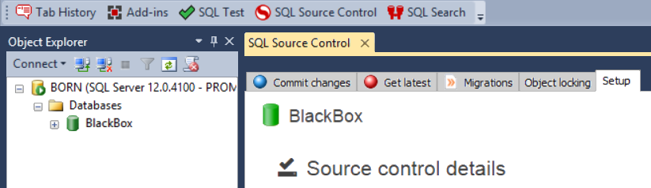

Each time a change (commit) is made, the user must enter a description for the change

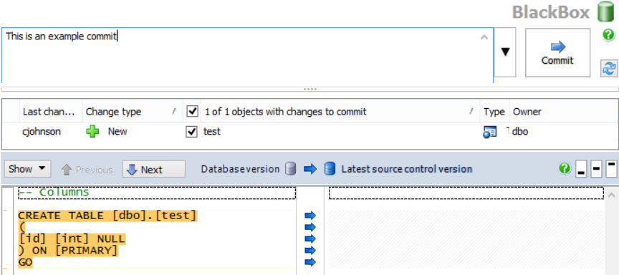

Reports and documents should be saved following each sign off to the corresponding folder in GitHub

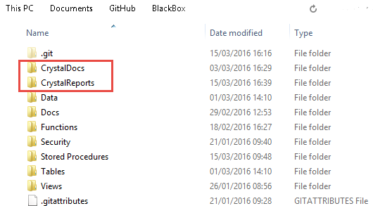

Changes (commits) made require a description

